**Andy(朱益煊)**

**Class One Grade Four**

**No.39**

**My model**

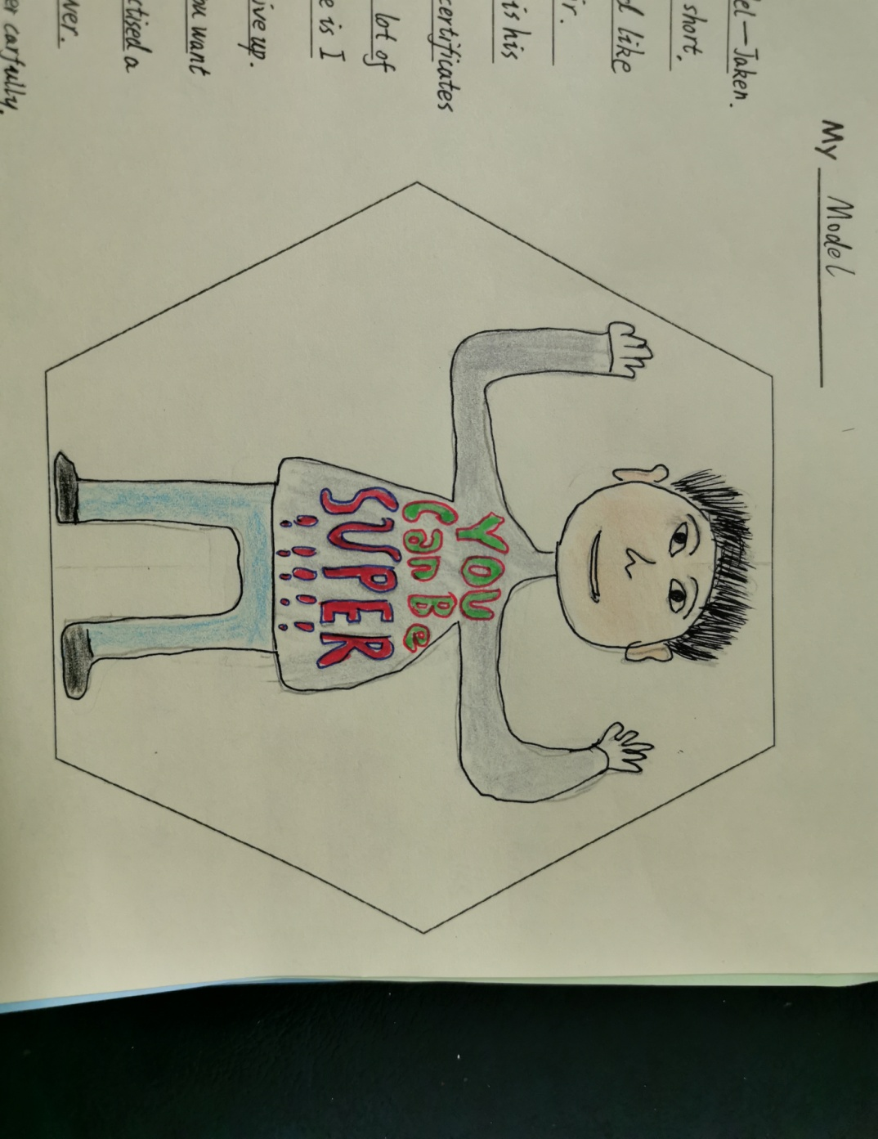

Today , I want to tell you something about my model——Jaken.

First I will talk his appearance. He is short. He has a small and round face. His eyebrows are curved like the crescent moon. And he has pointy hair.

Playing the unmanned aerial vehicle is his hobby. Last term, he won a lot of certificates on it. After that , I asked him‘Why can you won a lot of certificates?’His answer shocked me. He said‘I love it. I practice it a lot and I never give up.’This answer surprised me. I have got a point: If you want to be very good at something, you should love it, and practice it a lot, and the most important thing is to never give up.

At school, Jaken always listens to the teacher carefully. At recess, he just reads books or talks with his friends.

Jaken is a pupil like us, he is usual. But we can learn many things from him.

This is my model——Jaken, a hard-working boy.