Jonathan (郭泽轩)

Class Seven, Grade Three

No. 12

**My Dream Bedroom**

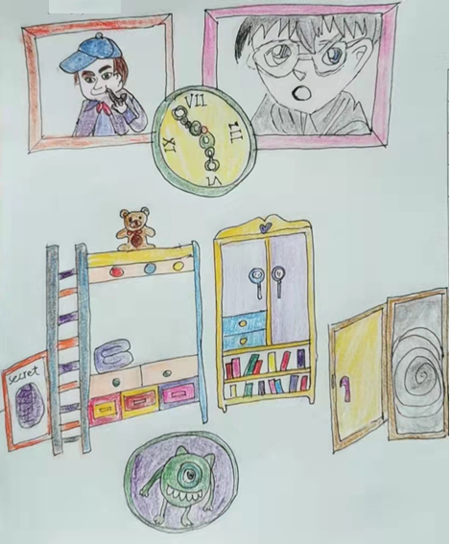

My dream bedroom is quite different from the real one. When you step into the room, you will see a big soft bunk bed against the wall. There are a few buttons on it. If you push the red button, the bunk bed can turn into a submarine. It can fly, dig a hole on the ground, or even blast into space. If you push the blue button, you will enter a secret room and see a lot of

stuffs I like, such as my favorite toys, board games, books and so on.

On the right side of the bed, there is a giant wardrobe. I put my clothes in the upper space and books on the bottom. The interesting part of the wardrobe is its knobs. They are actually magnifying glasses.

Above the wardrobe, there are two lovely portraits hanging on the wall. They are my favorite detectives. One is Sherlock Holmes, the other is Conan.

Between the two portraits, there is a fancy clock. Its hands are the shape of handcuffs and you can even talk to the clock when you feel lonely.

I like the door of my bedroom best. It’s actually a slide, a magic slide that can take you anywhere. Once you sit on the slide, think one place in your mind, like New York, Paris, Tokyo…Guess what! You will be there after you land on the ground.

What an awesome and amazing bedroom! I wish I could live in it one day.