Vivian(叶思慧)

Class Three Grade Five

No.35

**A Reading Review of “Last Chance”**

In the book *Last Chance*, Mike works for SFX News. He is a good news cameraman, but his boss Mr Frank does not think so. He gives Mike the last chance. In Hawaii a volcano is erupting. Mike goes there to film the story. Then a woman called Jenny is calling for help. Mike saves her and carries her down the volcano, but he loses his camera. At last, the camera is found. His film hits Mr Frank and he can work with Jenny.

I think Mike is a kind, friendly and brave man. When he is running out of the big fire, he hears Jenny asking for help and runs to save her although it is very dangerous. And he even loses his camera and the last chance of job for that. He is really brave and warm-hearted! There is something much more important than a camera or a job, such as life. You can find another job after all, but you have only one life. When someone needs help, I will also try my best to help him or her too!

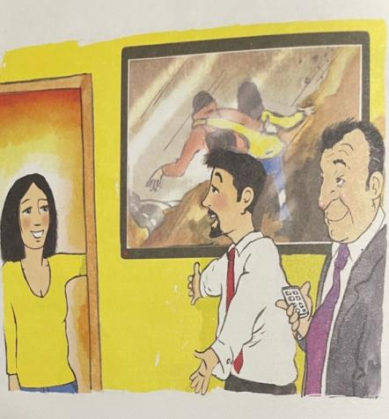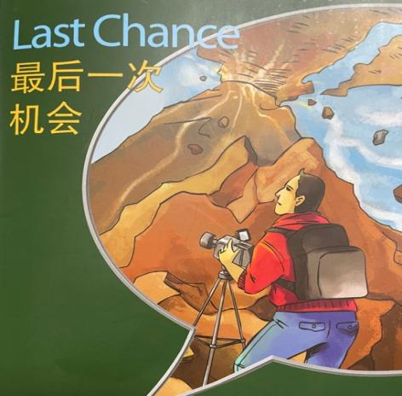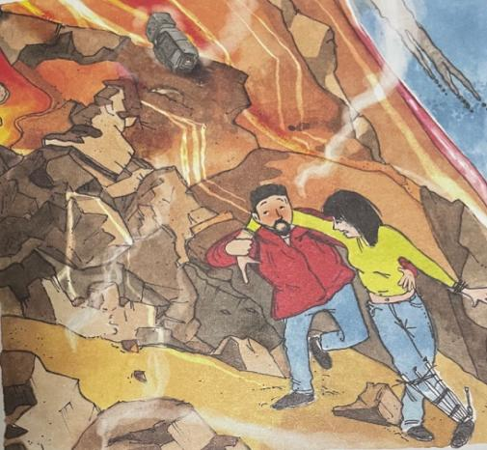Cherish life, life only have once.