Angus(朱梓睿)
No.39
Class 7 Grade 4
Where is Weeza’s scarf?
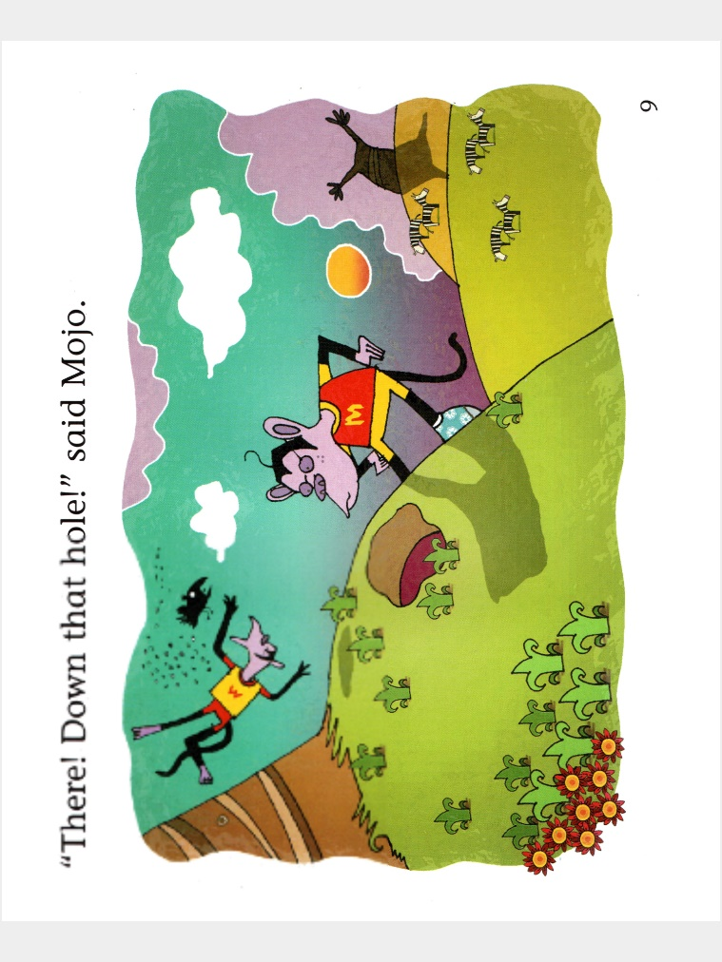
Mojo and Weeza looked very intelligent. Mojo had a new glove and Weeza had a brand new big scarf. Suddenly, there was an enormous gust of wind blew Weeza’s new big scarf away. “My new big scarf!” said Weeza. “It’s gone! Where did it go?” asked Mojo Weeza looked around and saw something in the tree and shouted “There! Hang on the tree.” However, it just a long thin rope.
“Look at there, down that hole!” said Mojo. But it wasn’t Weeza’s hat. It was a dirty paper and make Weeza neck dirty.

“Over there , in the grasses!” said Mojo. But it wasn’t Weeza’s hat. It was a angry harmless snake and nearly bited Weeza’s ear.
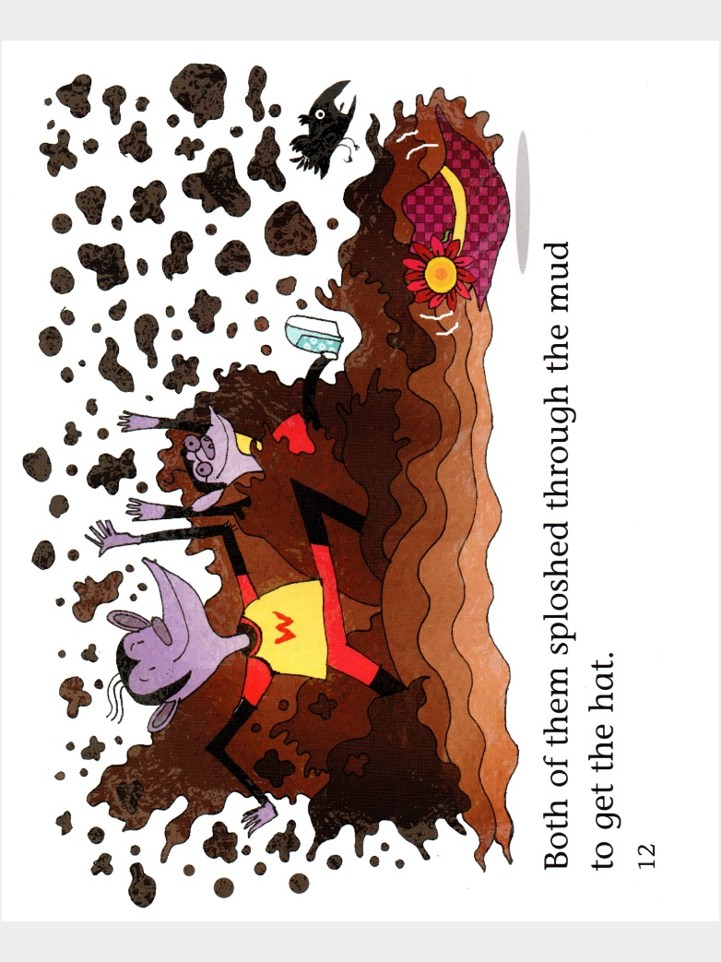
Weeza was so disappointed and sat down in the hole which full of muddy. Then Mojo saw Weeza’s new hat and shouted “There! On the elephant back” Both of them sploshed the mud to the elephant and get the scarf back.

“That’s better,” said Weeza, as he put his new scarf back on. The two of them full of muddy,but looked smart again… well, almost.

