Angus (朱梓睿)
No.39
Class 7, Grade 4
Dinosaurs
Dinosaurs lived on earth millions of years ago. There were all sorts of dinosaurs. Here were some of them.
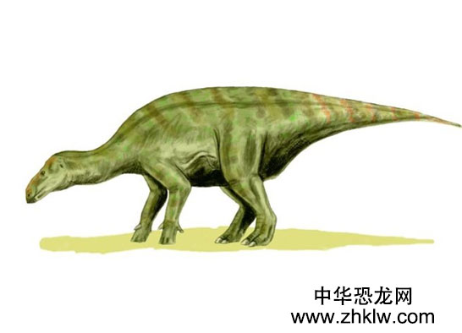
Lguanodons eat plant and they were gentle and they had the teeth which like lizards . They had long arms the scientists guessed that they needed the long arms to protect themselves.
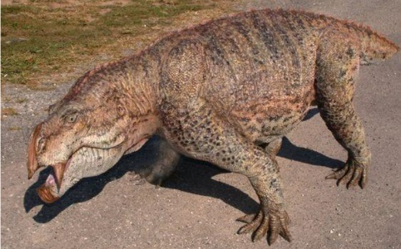
Cynodonts are reptiles. The appearance of these animal looked like dogs and had a clever brain.
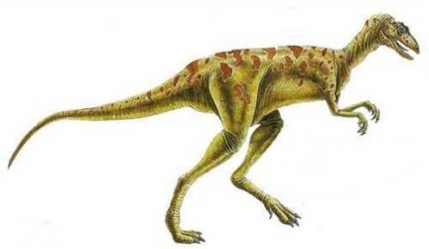
Coelophysis were thin and moved fast hunters. They were not gentle and had bad manner. Their length were about 2.7 metres.
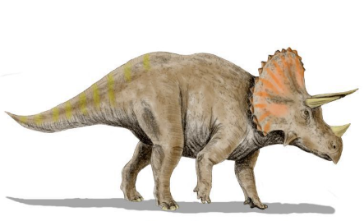
Triceratops had two long horn and one small horn. Their stomach were big.

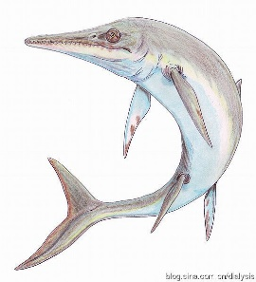
Ichthyosaurus looked like dolphin, they used their tail to swim fastly, they had thin,long,sharp mouth.

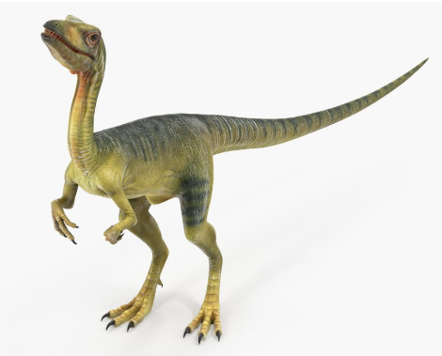
Velociraptor seem to born for speed and quick attack. They had three fingers on each hand. Their middle finger was the longest and the first finger was the shortest.

