Amy (陈迦瑜)

Class Six Grade Four

No.2

**Tod! It’s time to tidy up!**

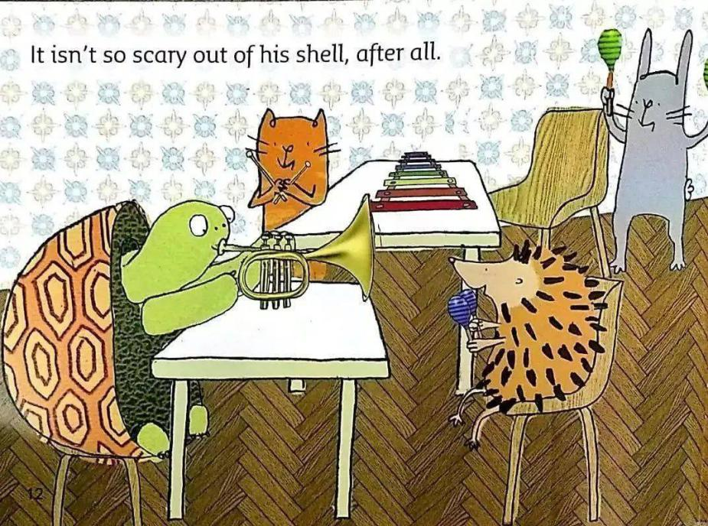 Tod is good at music. He often plays his trumpet. Tod is very shy. Tod likes to hide inside his shell when he’s feeling shy. He goes back to hide when it’s time to tidy up. Inside Tod’s shell he cleans his shell every day. But others don’t know that. The classmates think that Tod is lazy and messy. At school, nobody can see that he’s cleaning his shell. Nobody can see it. Nobody knows it. It is only Tod’s secret.

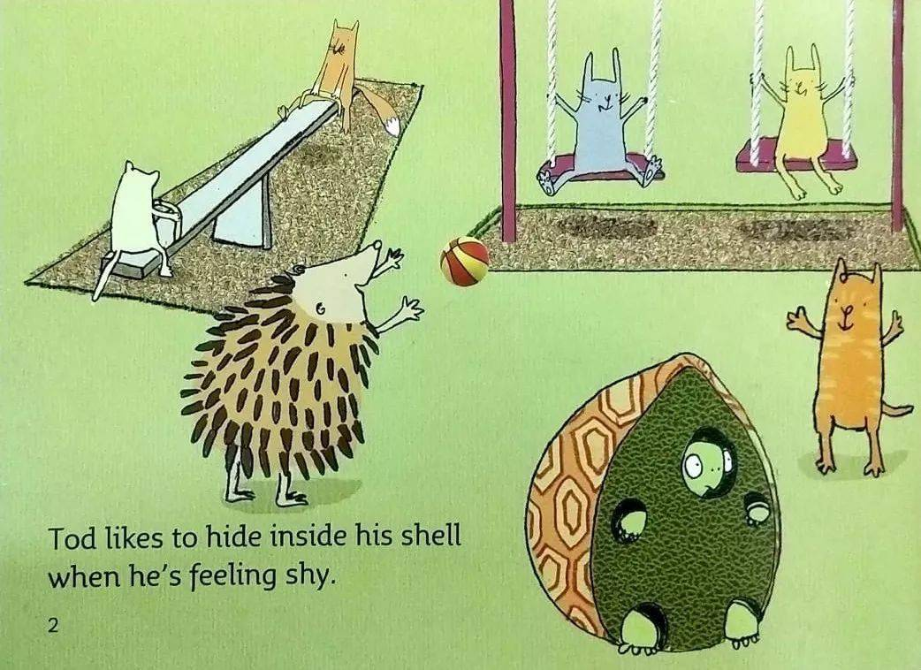It is May Day holiday today. Everyone helps to clean the classroom. Tod joins them. They all want to know who is better at tidying up. Tod is cleaning the classroom. He is slow. He does it all by himself. Nobody helps him. Tod is so shy that he doesn’t ask any classmate for helping him. After a while, Tod has finished cleaning the classroom. Tod gets the best. It is so amazing! Tod is happy to win the game. He shouts,

“I win! HHHHUUUURRRRAAAAHHHH!”

It is not so scary out of his shell, after all. Now Tod plays with his friends happily. He is not shy any more.