Angela（杨星瑶）

Class Eight Grade Three

No. 30

**My Tour at “The Land of Abundance”**

During the May Day Holiday this year, I went travelling to Chengdu, a wonderful place known as “The Land of Abundance”.

**Day 1 Wolong Panda Park**

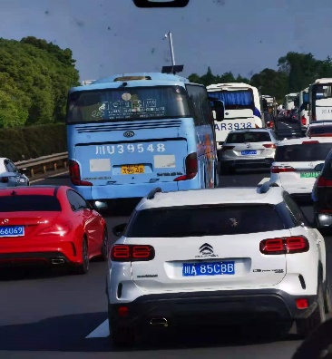Today is the first day of May Day Holiday, so we went to Wolong early in the morning.

But we met the big, big traffic jam. You could see a long car dragon. We were trapped in the bus for seven hours. When we got there, it was already 3 p.m.

We saw a big family of five pandas at that park. It was not common because usually one family only had one or two panda babies.

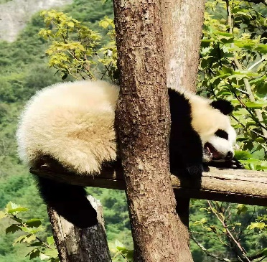I found one panda which was really cute. I first saw his white, big bottom. That was because he was sleeping on a tree. Some visitors said he stayed there all the day from morning until now.

**Day 2 Wenchuan & Four Girls Mountain**

Today, the first place we visited was Four Girls Mountain, a high mountain that has an altitude of 6,200 meters. A lot of members in our group, including my dad, had serious problems—altitude sickness. It was so unlucky that they couldn’t see the beautiful views. When I climbed up the mountain, the scenery was fantastic!

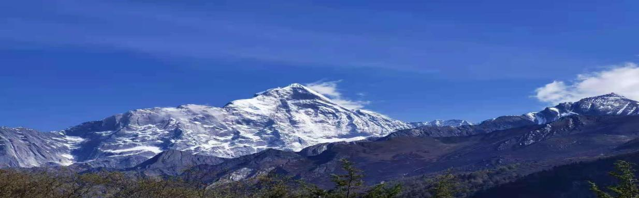

In the afternoon we went to Wenchuan, a place destroyed by the severe earthquake. At a middle school, we saw many broken houses there. I thought that things happening there were so sad. So many people died. I really couldn’t stay there any longer.

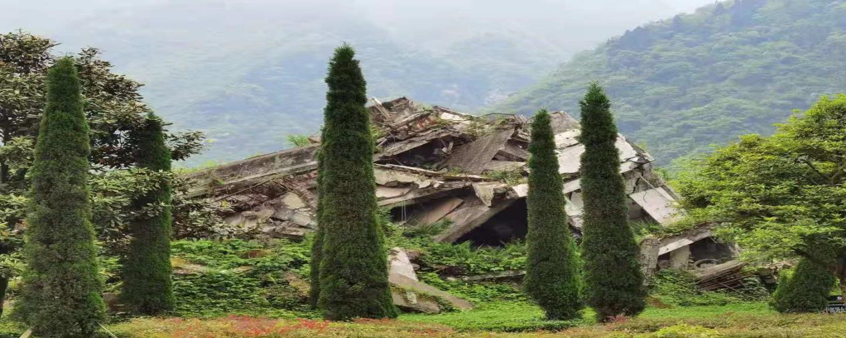

**Day 3 Dujiang Dam**

We went to Dujiang Dam on the third day, where we studied how to make full use of water for good things. My parents and I all love the work very much.

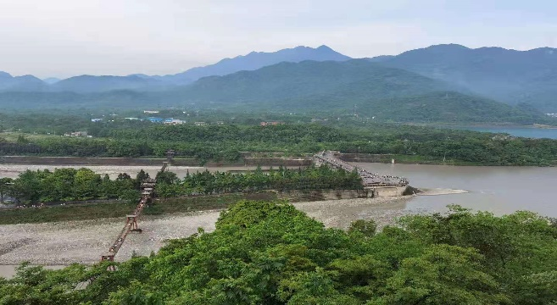My favorite part is Feisha Dam. The river water is spinning when it is moving towards the sea. So the sands in the river could be thrown away out of the river, like fish flying over the dam.

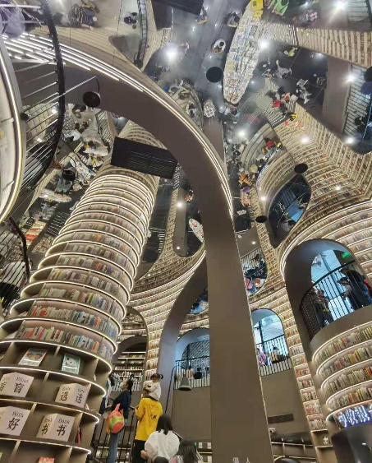After visiting Dujiang Dam, we also went to Zhongshuge, it is said to be the most beautiful library in China. But I thought it was the strangest library.

**Day 4 Sanxingdui Museum & Wuhouci**

Today we went visiting Sanxingdui Museum. But I was most interested in the ice-cream sold there. The ice-cream wasn’t big, but it was like a funny face. Some faces had open eyes. Some had open mouths and some had upward nose. But they all had long ears. At first bite, it tasted like strawberries. Then the next bite was the taste of milk. The third bite was the mixture of strawberry and milk. If you have one hundred bites, you will have one hundred tastes!

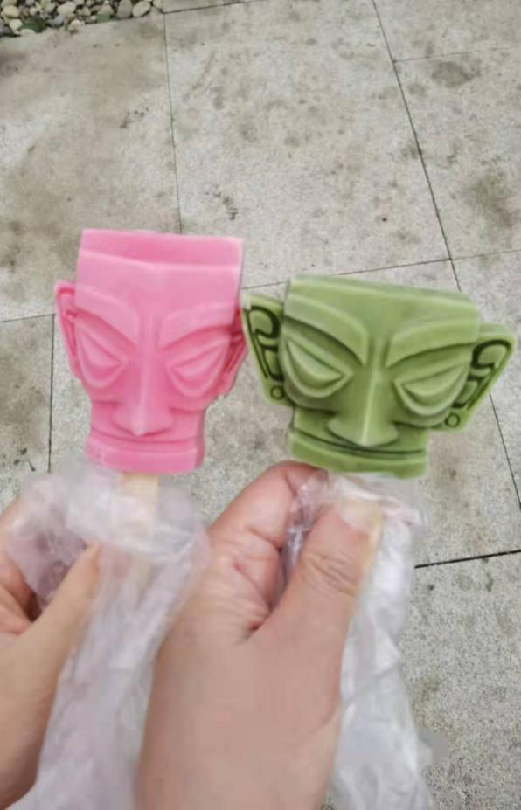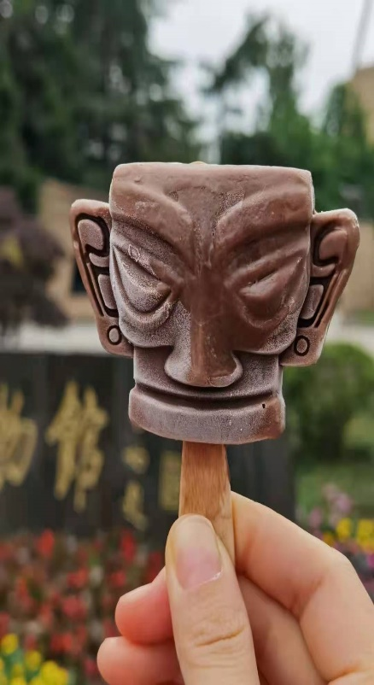

I also went to Wuhouci, a place in memory of Zhugeliang. I saw many statues of famous generals and poets from Three Kingdoms.

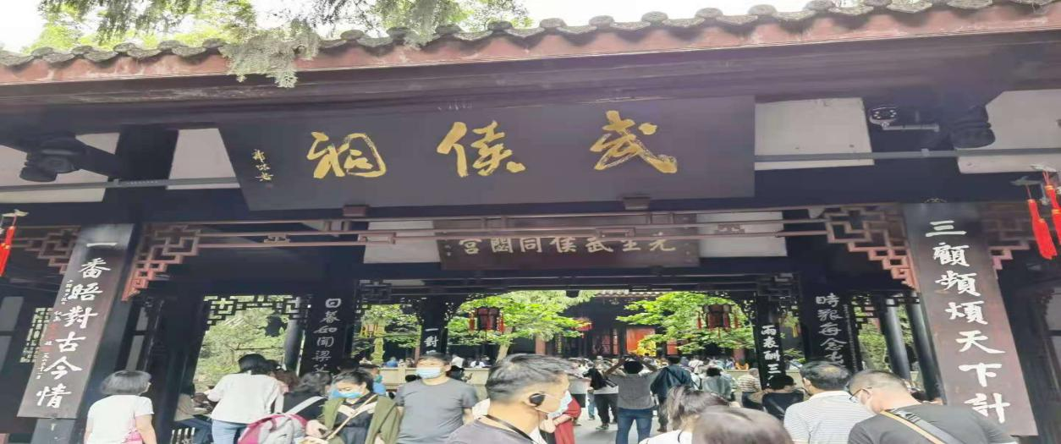

**Day 5 Dufucaotang**

Today is the last day of my tour. We went to Dufucaotang, a place in memory of the greatest poet—Dufu.

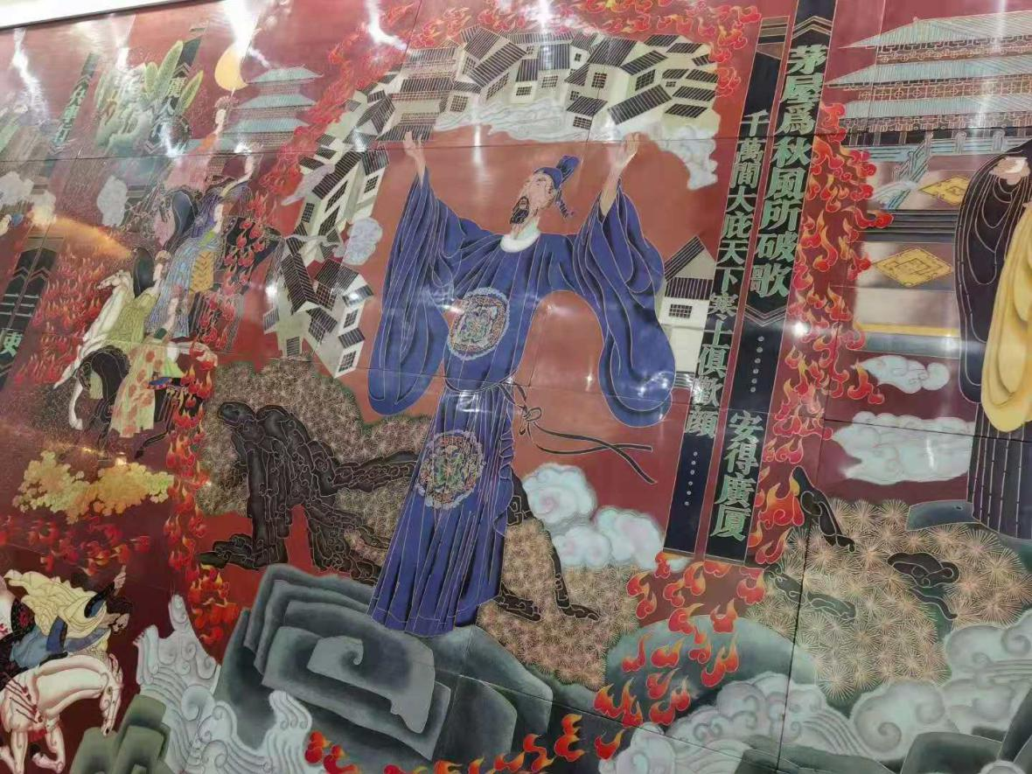My favorite part was the statues of the ten most famous poets. The funniest one was Libai. Li Bai was called as “Double God”, Wine God and Poem God. That was why his statue looked like a drunk person who was almost falling to the floor. Qu Yuan’s statue was funny too. It looked like a wood because Qu Yuan fell down in the river. Chen Zi’ang’s statue was the biggest one. Because in his poem, he believed that he was the only one in the center of the world.