Amy (陈迦瑜)

Class Six Grade Three

No.2

**Enjoy a hot spring**

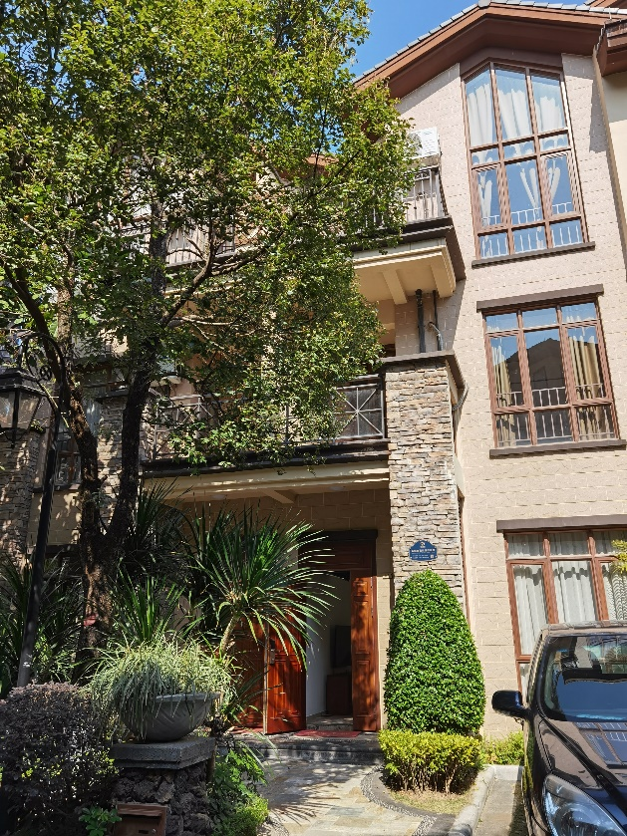In the winter vacation, we went to a big house to enjoy a hot spring. There are three floors in the house with four toilets and three bedrooms. There are also two hot spring pools. One pool is big, the other one is small. The big pool is on the first floor and the small pool is on the third floor.

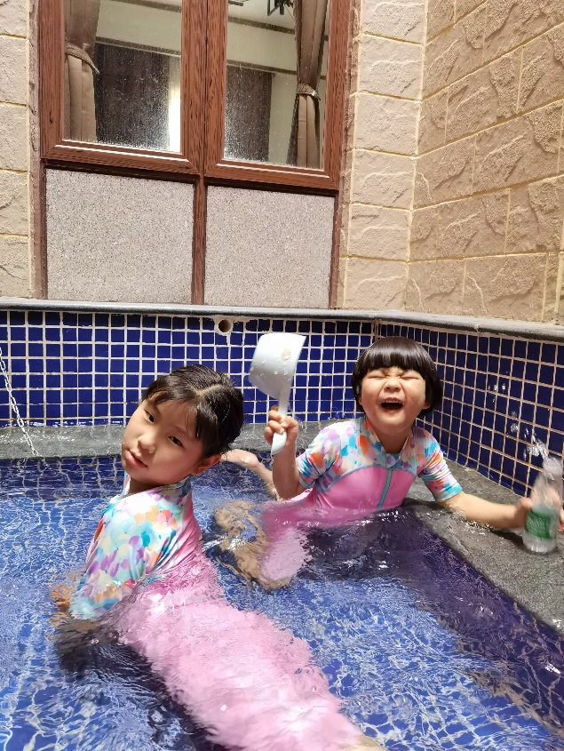My favourite activity was swimming in a hot spring. I felt relaxed and happy when I was in the hot spring. I liked playing in the warm water with my little sister. We splashed water to others. We swam in the water.

It was really fun to play in the hot spring.