Moon

Class Six Grade Three

No. 29

**My tumbler**

One day, I drank a bottle of yogurt. I looked at the bottle cap. I thought I can recycle it.

|  |  |
| --- | --- |
| 431252fb6acef85bd5ba3b656afb8bf1. First, I put some plasticene in the bottle cap. | 3407289082e5891c758aca25fcf8df92. Second, I drew a big Zongzi and coloured it. |
| f7ece796fa62fa7ab66f2629dac7d4a3. Then, I cut the Zongzi. | 30612c0df52ceb56ba2432231f57d0e4. After that, I stuck the Zongzi on the bottle cap. |

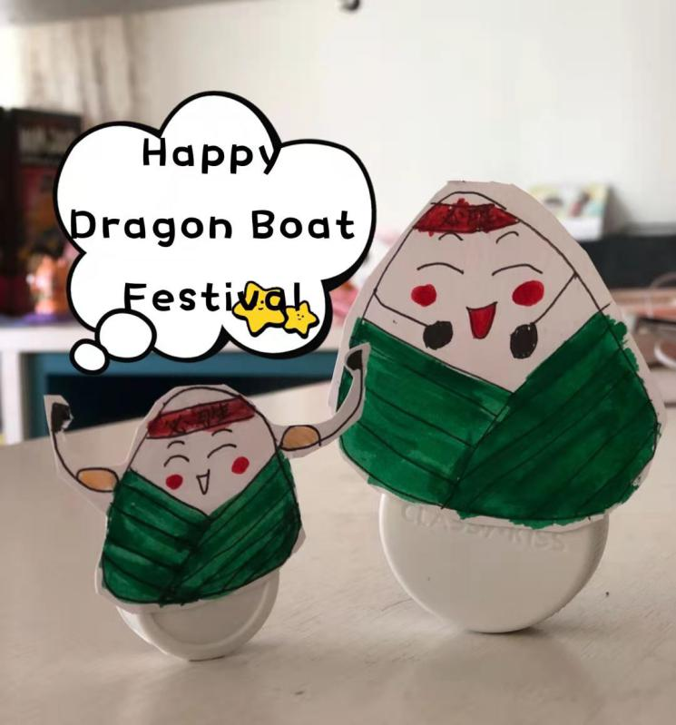

5. At last, a tumbler is finish! Yeah! I hope you can have a try.