## Tiger（税嘉陈）

## Class Three Grade Four

## No.24

Grammar Daily News

December 22nd, 2020

OREGAY!

How to write a Newspaper article?

——by Jerry

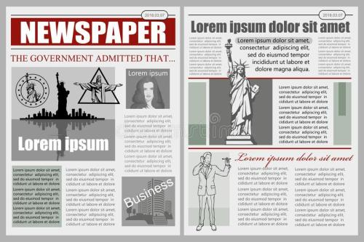Hello, I am Jerry. If you want to write a good Newspaper article,you should choose a good topic.It is the things that you will write. It is very important. .Maybe the old people would like to see something about how to be healthy, the man would like to see something about business,the women like to see some clothes, bags and jewelries. And the children maybe like to see something about toys or online games!

But if you only want to write one topic but not many topics, you can write the kind of the people that would like to see this topic. Let the people who is buying the newspaper knows him/her would like to see which newspaper!

And you should get many information and picture that is TRUE.The Newspaper article is a kind of informational text. It is telling the true fact of our true life!

And there are many parts of a Newspaper article: headline, byline, photograph and many parts. You can put these parts anywhere. Maybe the most shiny Newspaper article would have a different place of the parts!

This is how to write a Newspaper article. If you like it, tell it to your friends!

Do you like it (Yes or No)?_________________________________

AD time!

Are you hungry?

Are you sad?

Are you depressed?

Come on,

Let us eat the OREGAY COOKIES!

Address:Main Street,in Jerry mall

TEL number:857857857

Thanks for buying!

The multiple-meaning word

——by Jerry

Do you know a word can have more than one meaning? I think you know. But do you know what they called? Let me tell you: multiple-meaning word.

Now you know the name of these word, but......how about examples? I know you can find the examples but I will give you one first: round. Round has two meanings:1. the word that describe a smooth circle, 2.a time in the competition.

After this example, I think you will find more easily, like China,Chinese,hand......

Now you know these examples. But,when you are reading an article, you will see some multiple-meaning word. How can we explain what word stands what meaning?

Someone will know how easily. But someone needs to hear me to explain. OK, now, I have an example of using CLUES to find out the definition of the multiple-meaning word. Like “You should not speak Chinese in an English lesson.” In this sentence, Chinese has three meanings:1.a kind of language, 2.people from China, 3.things from China.

It is easy to find out clues in this sentence: “speak”.We can only speak a language, but not a person or a thing!

Now let us see another example: “China has 14.0005 billion people.” In this sentence, China has two meanings:1.a country, 2.a thing that is easy to break.

It is easy to find out clues in this sentence, too: “has 14.0005 billion people”.Let us just say......Why can a thing that is easy to break and has 14.0005 billion people? It do not make sense!

OK, I think you will know a lot when you see this sentence. Do you like it? Tell it to your friends if you like it!

Do you like it?

(Yes or No)

_________________________________________________

UNDERTALE Soundtrack

Do you want to have a really-good music adventure?

Do you want to listen to the ROCK MUSIC and the soft music?

Welcome to our website!

In here,

You can listen to the ROCK MUSIC like:《MEGALOVANIA》

Or the soft music like:《Once upon a time》

And they are all from one game:

《UNDERTALE》!

Go and download it!

And listen to these really-good music!