## Barbie（谢欣霖）

## Class Three Grade Four

## No.31

**Art grade examination**

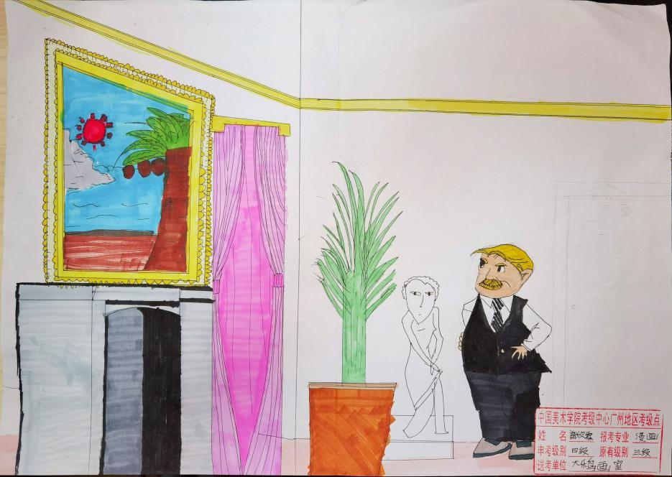

谢欣霖/Barbie

Class 3, Grade 4

– 2020年8月30日

Last Sunday, I went to the art grade examination at Daleniao Studio. At 9 A.M, the drawing examination of four grade was started.

I got a picture as the test question from the teacher and started to read the detail of it. In the picture, there is a gentleman on the left and a room on the right. There is a large painting, a fireplace, a window and a long curtain on the wall of the room. There is a status and a pot culture on the floor. My job is to draw all the things in a piece of A3 paper and put them into a right place in the room.

I drew the room first, and then I drew the man facing the wall. The man was looking at a beautiful painting on the wall. In this painting, I drew a coconut tree on the seashore on a sunny day. I drew the window on the wall and the curly curtain next to it. On the floor, I drew the pot culture and the status.

When the outlines of all the things were drawn, I marked the outlines with a pen. After that, I painted them with different colors. For the man, I painted the hair in gold, the cloth in black and the shoes in gray. For the painting on the wall, the frame is yellow, the sun is red, the coconut tress is green and brown, the seashore is light brown and the sky is blue. The fireplace was painted black and white. The curtain was colored pink. For the pot culture, the green plant is growing in a coffee cold pot. I left the status white.

The examination was set to 2 hours and I finished drawing in 1.5 hours. I think the test question was easy and I am sure I can qualify for the art grade examination this time.