## Simon（谢念衡）

## Class Three Grade Four

## No.30

**A Trip In Summer**

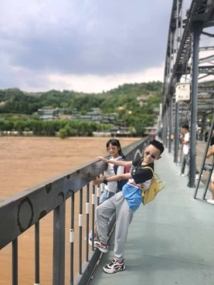 This summer, I had lots of fun with Helen and Sophia. What impressed me most is the trip of Gansu.

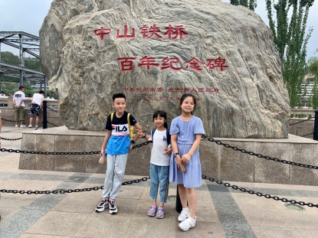 On the eighth of August, we went to the Zhongshan Bridge to see the Yellow River. The water was yellow because it has a lot of silt, and the water was very cold. We installed some Yellow River’s water and I drank some.

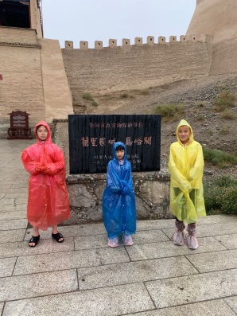

On the eleventh of August, we went to Jiayuguan to see the Great Wall. We climbed on the Great Wall. The Great Wall was a bit high. Jiayuguan was very big because it was a military fortress.

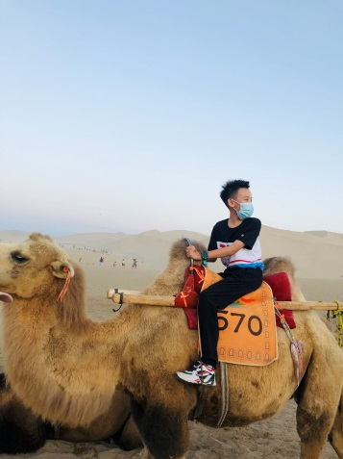 On the thirteenth of August , we went to Mingsha Mountain and Crescent Spring. Mingsha Mountain was the mountain built by sand.We rode the camel, that was fun.

These are the most fun things in this trip. I am waiting for the next travel.