## Tiger(石浩玮）

## Class Three Grade Four

## No.22

***BaiYun Mountain***

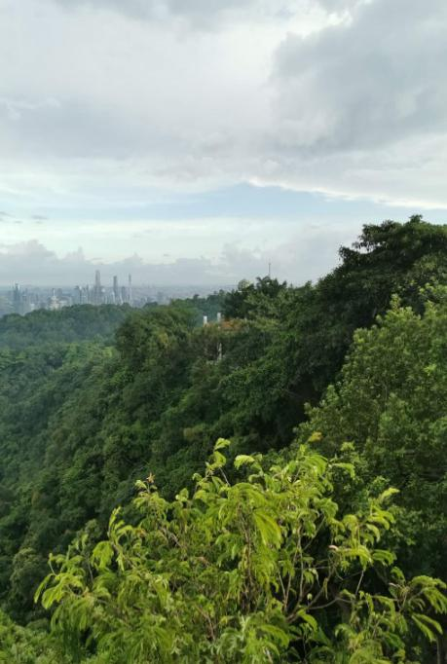On the holiday, I went to the BaiYun

Mountain. Let me tell you more. It is

very high. You can breathe the fresh

air everywhere.

You also can see the clouds on the

mountain. Sometimes they look like

dogs, and sometimes they look like

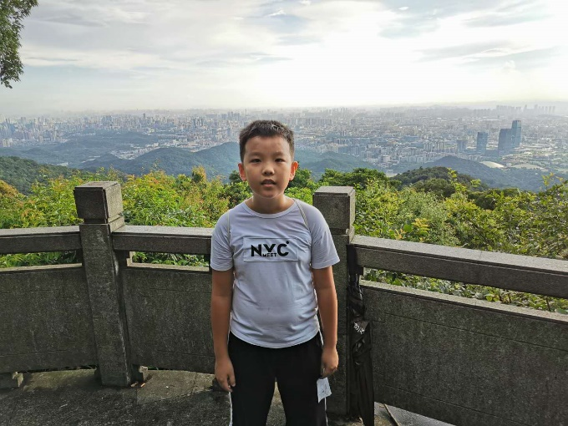wolves…Birds like this place because there are many trees, flowers and grasses. And there are also some food for birds in the trees and grasses. You may ask, “What food?” Let me tell you, they are fruits and pests.

Do you like BaiYun mountain?