**The toys party at night**

Natalie Luo, Class 7 Grade 4

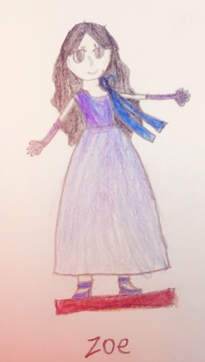Ann is a little girl, she loves a toy named Zoe. She plays with Zoe every morning, she thinks all the toys are lifeless. But in fact, actually the toys have life!

At night, all the people go to sleeping, the toys begin to move. “Hello!” says Zoe, ” We can do many things. We can have drawing game, dancing game and a fashion show!”

The car named Tom, he is shipping some toy cloths, and the dolls wear them, the fashion show begins. Bule, yellow, red……So beautiful!

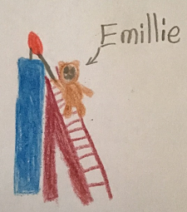Emillie the bear and Amy the dog take some candles for lamp, the Ethel cat finds some crayon and a piece of small paper, and then the toys can draw on it.

The dancing game begins too. The Tian pig wears a white dancing dress and a pair of white shoes. She dances very well. All the toys clapped and cheered for her.

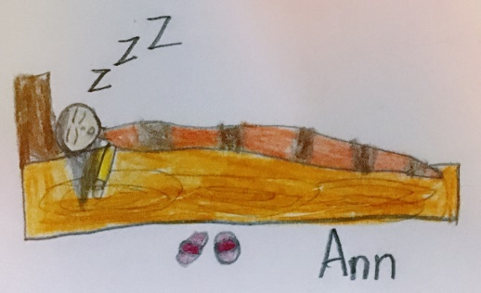The party is over, and all the toys play happily. But Ann still sleeping, she doesn’t know the toys are living, and they just finished their party.