**Persistence**

Grade 4 Class 4 Kathryn黄子衿 12号

Badminton is an interesting sport. Sometimes, it’s very funny, and sometimes it’s very hard. But if you keep playing and practicing, you’ll gradually master it and enjoy it.

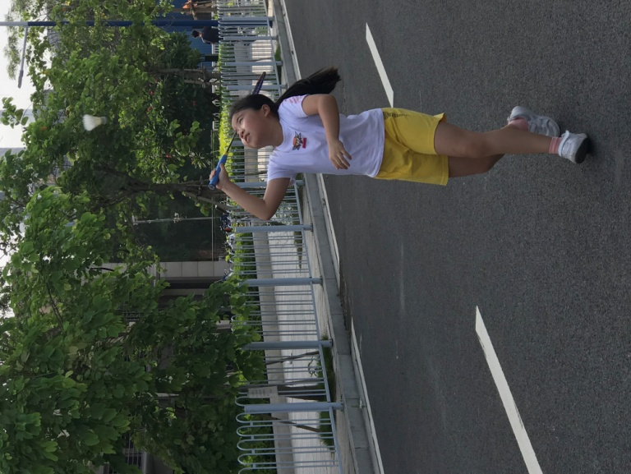Recently, I always practice badminton，I can’t play it well. I just can bat the ball to my dad， but when my dad bats the ball to me，I can’t receive the ball. The second day ，I still can’t receive the ball. The third day，I still can’t receive the ball…… I feel sad. But I tell myself not to give up，so I keep practicing. Now, I can play badminton very well.

Maybe sometimes you think something is difficult. But if you keep doing it, your persistence will be rewarded.