Chris (王境嘉)

Class Two Grade Four

No.30

**Thoughts on reading *Snoopy***

This winter, I read an English comic. Its [protagonist](javascript:;) is a dog called Snoopy. It’s a [series](javascript:;) of Peanut Comics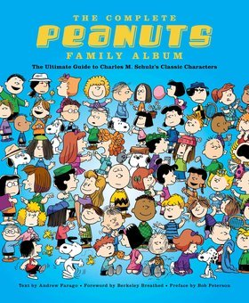. Snoopy’s owner is Charlie Brown. He has only three hairs. He’s an [optimistic](javascript:;) boy. The comic tells a lot of stories between the kids and Snoopy. Here are some pictures about the book: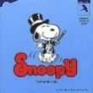 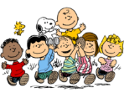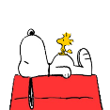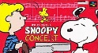. Sometimes the kids like Snoopy, because he is cute. Sometimes they hate Snoopy, because he is gluttonous. He can even hear Charlie wrapping a candy when he was asleep. I read [Volume](javascript:;) [One](javascript:;) and Volume Two. There were many characters, Snoopy, Charlie Brown, Lucy, Patty, Violet, Lucy’s baby brother Linus, Schroeder, and‘Pig-pen’. Lucy was bit narcissism. She was also [arrogant](javascript:;). She gets a lot of troubles by her arrogant. One time, Lucy wanted a cup of ice-water. Charlie brought an ice-cube. Lucy was angry because she thought Charlie’s hands were dirty. Charlie was angry too. He threw the ice-cube onto Lucy. Patty was cute and pretty. But sometimes she was mischievous. Once she told Lucy about her ‘Mad Money’. She said that ‘Mad Money’ was for… Then she hit Charlie Brown with the ‘Mad Money’. Violet was prettier. She was cute, honest, and polite. One day, Charlie made a snowman. Violet saw it and said ‘Incredible’. It’s nice for anyone to commend others. Linus appears a little in my books. But he has strong hands-on skill. He could make a tower with Poker. And he made a doghouse with bricks for Snoopy. Schroeder was mad of toy piano and Beethoven. Once Charlie Brown gave him a present, it’s a Jack-in-the-box. When he opened the box, a Beethoven statue popped out. He loves it very much. ‘Pig-pen’ was new. He was dirty. Actually, he didn’t know his name, but many people call him ‘Pig-pen’. One day, Patty wants to clean him. But she found that ‘Pig-pen’ has cleaned up. In fact, he cleaned a half of himself.

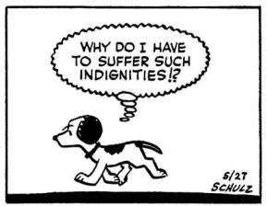 The Peanuts comic has lots of pictures. Almost every time four pictures are a story. Some stories are interesting. I can introduce them to you. Someday in winter, Charlie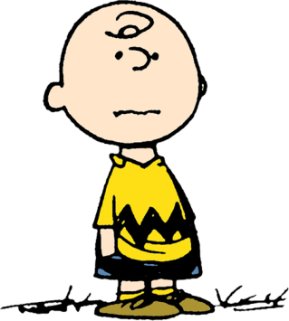 saw Schroeder crying. Then he made him a snowball. Schroeder stopped crying. He gave him the snowball. Then Schroeder threw the snowball onto Charlie. One day, Charlie saw Snoopy singing. He said ‘People shouldn’t embarrassed just because they get caught acting a little silly’. Snoopy got angry.

Snoopy is funny. In this holiday, it gives me fun and joy.