Chris (王境嘉)

Class Two Grade Four

No.30

**The Solar System**

As we all know, the solar system has eight planets, a dwarf planet, and a fixed star. The eight planets are Mercury, Venus, Earth, Mars, Jupiter, Saturn, Uranus, and Neptune. The dwarf planet is called Pluto. Many people will ask a question, including me; witch planet is bigger, Jupiter or Saturn? I read a book to find out; it says that Saturn is smaller than Jupiter. But Saturn is similar to Jupiter, because they’re both huge planets made of air.

As the development of the [technology](javascript:;), scientists found a new mystery. Near our solar system, there is a ‘fixed star factory’. Scientists think, about four point five billion years ago, the sun was born there. There are a lot of grey cloud cluster. Every cloud cluster has two fixed stars. They are called a pair of double stars. The brighter one is called the [primary](javascript:;) [component](javascript:;), and the darker one is called companion star. But if the sun was born there, where did its companion star go? Because if the sun’s companion star was somewhere in the solar system, the earth won’t be like what it is today. So the sun’s companion star can be anywhere in the outer space. We can even say the sun’s companion star is one of the stars above us. Scientists explain that the sun’s companion star is more likely to have been thrown to another place because of a strong attractive force.

Now, I’m going to tell everyone about our solar system. The nearest planet to sun, Mercury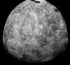 is a rock ball surrounded by cliffy mountains. In the morning it’s over 400 degree centigrade. At night, the temperature drops very fast. The temperature sometimes can be -170 degree centigrade. Mercury is smaller than earth. Earth is about two point five times bigger than Mercury. And it has no [secondary](javascript:;) [planet](javascript:;). Venus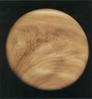 has a deceptive look. Scientists used to think Venus is similar to earth, but now they see that Venus is more dangerous than we thought. Its lightning appears 20 times per minute. The space probes scientists send to Venus had been crushed before it can send any massage back to earth. Scientists think four point five billion years ago, Venus looked like earth. The reason of why Venus becomes worse and worse is that Venus has no magnetic field to protect it. Earth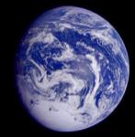 is our planet. Someone will ask that what’s different about Antarctic and Arctic. There are a lot of differences. Polar bears only live in the Arctic, and penguins live in the Antarctic. The Arctic is north, the Antarctic is south. The Arctic is a frozen ocean surrounded by land. The Antarctic is a frozen land surrounded by ocean. The earth’s atmosphere is made of [nitrogen](javascript:;), oxygen, and carbon dioxide. We human beings need oxygen, and plants need carbon dioxide. Mars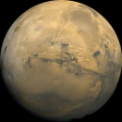 once been thought that there is life on there. But now, scientists realized that there are only little water and oxygen on Mars. What makes Mars so red? Of course its dry, desert looking dirt, sand, and rocks. They caused Mars’s sky to be red. A mountain called [Olympus](javascript:;) is on Mars. This mountain is the highest, biggest volcano in the solar system. Jupiter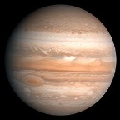 is a planet made of air. It has a mystery for a long time, its great red spot. Its storm can perform in a polygon, like square, pentagon, hexagon, heptagon, even an octagon. It’s a dangerous place because of its strong [radiation](javascript:;). Saturn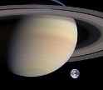 is famous for its seven rings. The rings are made of rocks and ice. Saturn is about tentimes bigger than earth. Uranus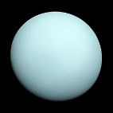 also has rings. But it has a special place. It is banked**.** There is lots of [statement](javascript:;) of why it’s banked. Someone says because a little planet crashed onto it before. Someone says it’s because the sun’s attractive force pulled it. Someone even says that its moons attract them. Uranus has many oceans around it, but it’s no good to swim there. It’s over 2200 degree centigrade water will heat you up. Neptune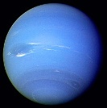 is about 4 times bigger than earth. At first, scientists thought Neptune has only two moons. Then, in 1989, Tourist Two found six smaller, darker, moons. In 2002 and 2003, scientists found five more moons. Now, Neptune’s thirteen moons have been found. In fact, Uranus helped us find Neptune. Scientists realized that Uranus had been slow sometimes. They thought a planet’s attractive force pulled it. Then they found Neptune. We know just a little about Pluto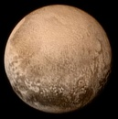. Pluto has a moon called Charon. Charon is almost as big as Pluto. In 2018, someone sent a picture to the internet. It’s about a heart shape on Pluto. Now many scientists are still studying Pluto.

Our solar system is big. What will its future be? Are there any planets we didn’t find them? The next one to discovery them will be you.