Amy (林小艾)

Class Two Grade Four

No.21

**The peacock**

Long time ago, there was a peacock, it was very proud, it thought it was the prettiest animal in the forest. Do you know why? Because it had a beautiful crown, a long blue neck and a colourful tail, it just looks like a king. It often spread its tail to show itself, everyone didn’t like it.

One day, the peacock went to the pond and it wanted to drink water. Suddenly she saw a white swan swimming happily in the pond. The swan wore a white clothes and had a pretty neck, the neck’s shape like a 2. The peacock thought: “I am prettier than it, so I must learn how to swim, I will be better than it.” So it intentionally said modestly: “What a beautiful swan you are, Miss Swan! I want to learn how to swim, can you teach me, please?” The swan never seen the peacock so modest like that, so it answered: “OK!” After that, the swan taught the peacock how to swim, the peacock practiced everyday.

In Autumn, the water of the pond became cold, everyone was afraid of cold and didn’t go to swim. Only the peacock kept swimming. It was half a year later, the peacock learned how to swim, at the same time, it wanted to spread its tail again. But do you know what happened? Although it tried to open its tail again and again, it couldn’t open its tail, it was long time no use its tail. It was sad and worried. This time, a rabbit told it: “Because you always go to swim, so your tail is tired, wet and heavy. If you don’t go swimming anymore and practice open your tail, you can open you tail. The peacock said: “My tail is no longer the most beautiful in the world.” It cried.

From then on, the peacock didn’t go to swim, it was not proud anymore, it knew everyone was different from others, we can’t copy what others do.

The story tells us, everyone has something to be good at. No one is the most powerful person in the world. We need to learn from others, and be ourselves.

***The peacock:***

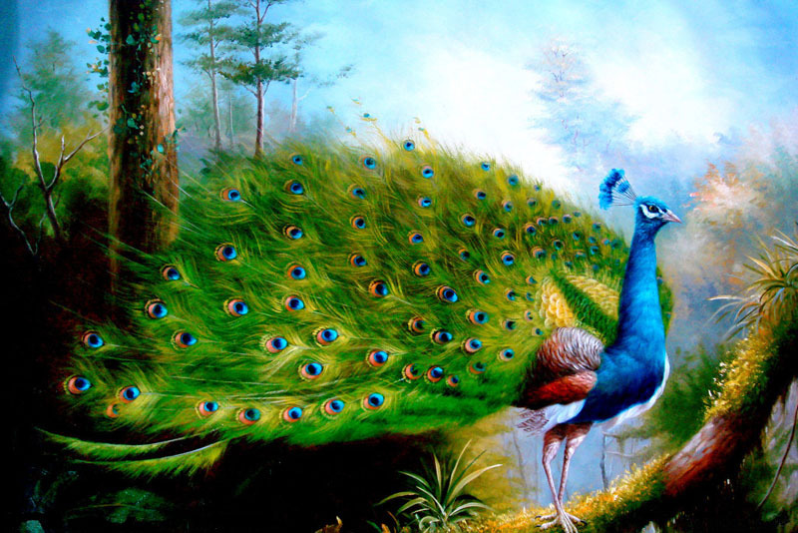

***The swan :***