Leo (刘科荣)
Class Two Grade Four
No.23
When My Mother Was Young
Today my mother told me something about she was young. I like her story very much.
The family before 1980 was really poor. There were less clothes to wear. There wasn’t any cup noodles or chewing gum to buy on streets. In market, there even had no cola. My mum’s childhood was hard. She lived in Yangjiang when she was three. She could even only saw her parents nearly ten times a year. When she was seven, she moved to Guangzhou. She could see her father once or twice a week, but she seldom saw her mother, because her mother went to the college to study. At the age of eight, she could always see her father now. But sadly, she seldom saw her mother for many days. At the age of twelve, my mother could finally see her mother every day.
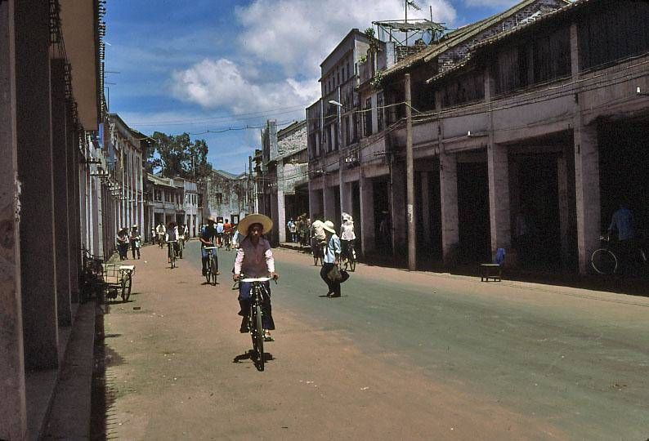
The story is a sad story. My mother was poor when she was young. I’m much happier than my mother. I have to cherish it.

