*Susie* (杨麒琬)

Class Two Grade Four

No.34

***Comparative and superlative***

*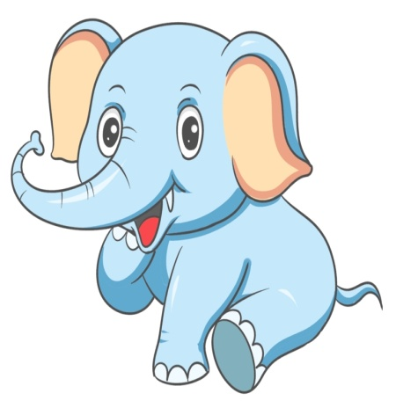The mouse's nose is long.*

*The mole's nose is longer*

*than the mouse's nose.*

*The elephant's nose is the*

*longest of all.*

*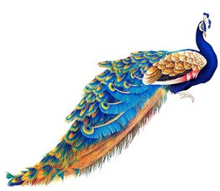The sparrow' s feathers are pretty.*

*The Kingfisher's feathers are*

*prettier than the sparrow's.*

*The peacock has the prettiest*

*feathers.*

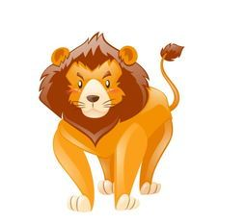

*The crocodile is dangerous.*

*The snake is more dangerous*

*than the crocodile.*

*The lion is the most*

*dangerous.*