Yao Chenxin

Class seven Grade three

NO. 35

**My Brother**

I have a brother, his name is Shawn. He is one and half years old. He has a big head, a little nose, a little mouth and two big eyes. He is very cute.

My brother likes balls.But he doesn’t know how to play. He can only throw the ball with his hands. So I want to teach him, but he doesn’t learn, so I only play with him.

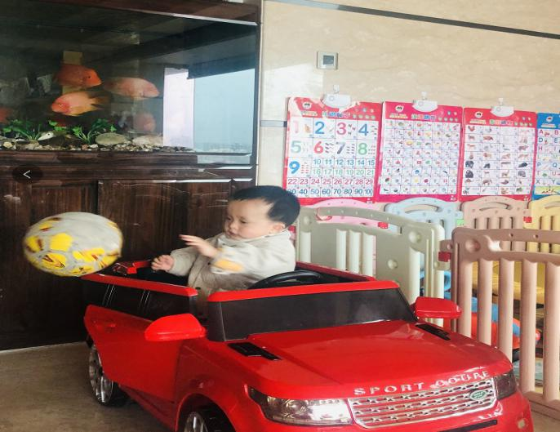

My brother likes cars too. He has two ways of playing. One is throwing, the other one is from the slide to the ground. If it is a car you can ride in, he will climb up and down.

My brother is really cute and naughty. I love him！

